Submissions & Assigned Tasks V.0.1

# Submission 1:

What is it?

PSP Documentation. The Project Planning Log must include the estimated times our team has devised at the start of TP02 and the actual times of our effort. We do not submit Individual Logs this time, but instead submit one big lumped up file using Subversion. Also, the PSP will include the Project Time Log. Even if two people are working on the same task, their own work must be recorded on a new line in the chart.

Who works on this?

All members of Team Echo will be working on this. As stated previously, these logs will document all of our group’s effort.

# Submission 2:

What is it?

Summary of changes made to use cases created in TP01. Were the use cases modified? Were there any use cases that were deleted? Were new use cases created? If there were new use cases, provide the entire use case diagram and description.

Who works on this?

Brian and Brendan. Why? Because these two were the constructors of the previous program’s (TP01) use case diagrams and descriptions.

# Submission 3:

What is it?

Provide use case scenarios for all use cases. Exactly what is a use case scenario? The scenario is the story telling the interaction of the use-case in a particular process. See page 339-340 of Schach book in Chapter 11.

Who works on this?

Brendan. As the Scribe, this would be flushing out the use case descriptions he had previously created.

# Submission 4:

What is it?

Provide a class diagram of all entity, boundary and control cases with the type of class clearly identified either by a sterotype icon or in prose surrounded by “<<” and “>>”. Also include the established class attributes and relationships. Exactly what is this class diagram? See page 341-343 of Schach book in Chapter 11. Also see, page 351-356 of Schach book in Chapter 11.

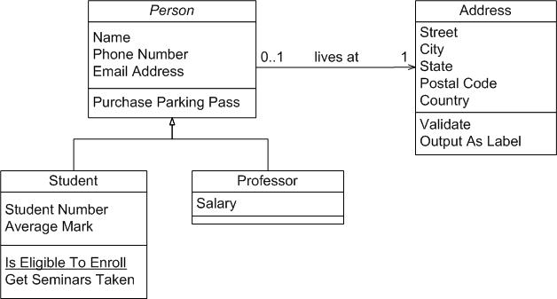

Who works on this?

Brian. As the Designer, he will be responsible for flushing out his previous use case diagrams into these class diagrams.

# Submission 5:

What is it?

Provide a statechart for each class. Exactly what is a statechart? See page 345-347 of Schach book in Chapter 11.

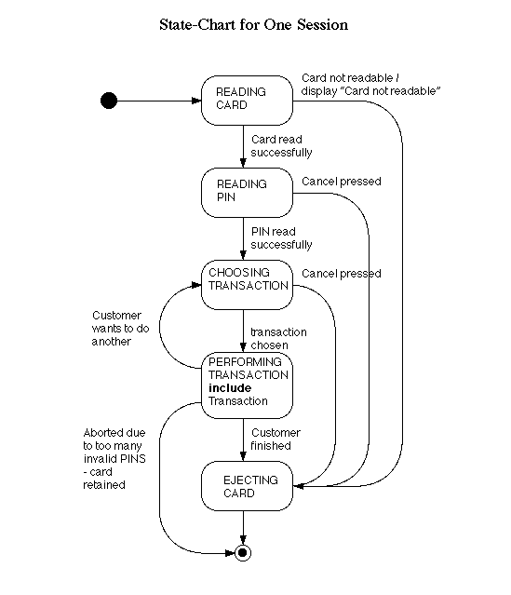

Who works on this?

Brendan and Brian. You two decide on how you want to split these. Technically, Lindsey could work on these as it directly relates to the sequence diagram, but I believe this should be created prior to the sequence diagram and thus Brendan or Brian can do the task.

# Submission 6:

What is it?

Provide a communication diagram for a single, multi-scenario use case. Note that you may use guard conditions, conditionals and other defined UML communication diagram notation to include both the main scenario and exception scenarios within the same communication diagram. If the diagram becomes clustered, it is suggested that you break some of the scenarios out and put them into their own communication diagram.

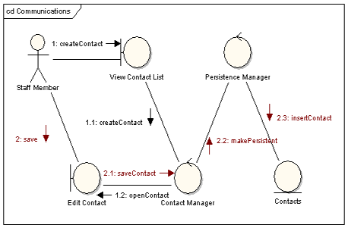

Who works on this?

Brendan and Brian. Only one Communication Diagram need be created, apparently.

# Submission 7:

What is it?

Provide a sequence diagram for each use case scenario. Note that you may use sequence fragments, guard conditions, other defined UML sequence diagram notation to include both the main scenario and exception scenarios within the same sequence diagram. If the diagram becomes cluttered, it is suggested that you break some of the scenarios out and put them into their own communication diagram. Exactly what is a sequence diagram? See page 368 of Schach book in Chapter 11, page 372 of Schach book in Chapter 11. Etc.

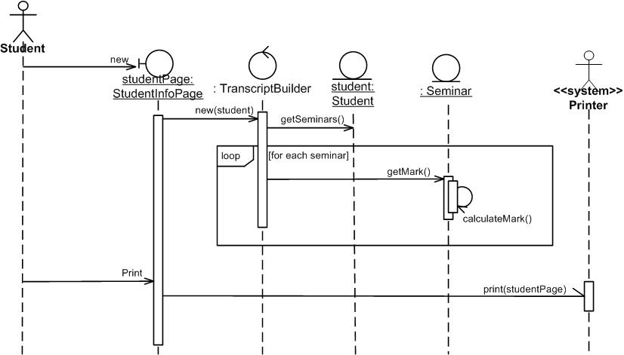

Who works on this?

Lindsey will be working on the Sequence Diagrams, as she can later review Brendan and Brian’s work to create these (this gives her time to finish the SPMP).

# Submission 8:

What is it?

Software Project Management Plant (SPMP). This is something Lindsey is currently working on, and will act as a reference for both the team and the customer.

Who works on this?

Lindsey will be conducting this lengthy draft of words in the early part of TP02 in order to have a reference for all team members to know where this project is heading, for both the customer and the team.